Vertical high-voltage GaN pin diodes on Si
Yuhao Zhang^{*1}, Daniel Piedra¹, Min Sun¹, Jonas Hennig², Armin Dadgar²,
and Tomás Palacios ¹
¹ Department of Electrical Engineering and Computer Science, Massachusetts Institute of Technology, 02139 Cambridge, USA
² Institute of Experimental Physics, Otto-von-Guericke-University Magdeburg, 39106 Magdeburg, Germany
GaN-based devices are excellent candidates for high-power switching applications. Currently, both vertical and lateral devices are being considered. GaN vertical devices have attracted increased attention recently, due to their high breakdown voltage (BV) and current capability for a given chip size, and superior thermal performance [1]. Record BV vs specific on-resistance (R_{on}) performance have been demonstrated in GaN vertical transistors and diodes recently. However, current GaN vertical devices suffer from the need for expensive GaN substrates, which has become a main obstacle for their commercialization.
In 2014, we demonstrated the first GaN vertical devices on low-cost Si substrates with a BV of 300 V and R_{on} of 10 mΩ·cm² [2-3]. Recently, fully-vertical GaN-on-Si diodes were also presented by different technologies [4-5], with a BV of 288-350 V and R_{on} of 3.3-7.4 mΩ·cm². Despite these promising results, the R_{on} and BV still need improvement to be competitive.
In this work, we demonstrate quasi- and fully-vertical GaN-on-Si pn diodes with record performance. High-quality GaN epi-layers as thick as ~3.7 µm were successfully grown on 2-inch Si substrate and ~3 µm transition layers [6]. Due to the limited total thickness of the GaN epitaxy on Si, the optimization of the thickness and doping in each GaN layer is the key to achieve superior BV~R_{on} trade-off: (a) The n⁻-GaN was lightly carbon-doped to compensate the non-intentional-doping, which enabled a low donor concentration (N_{D}) ~1×10¹⁶ cm⁻³. (b) The n⁺-GaN is highly-doped with N_{D}>10²⁰ cm⁻³. According to 2-D TCAD simulation, this highly doped n⁺-GaN allows a higher current density and a much more spread current distribution in the drift region, and therefore lowers the R_{on} of quasi-vertical pn diodes.
Our quasi-vertical GaN-on-Si pn diodes were demonstrated utilizing an optimized deep etching process and advanced edge termination technologies. The fully-vertical diodes were fabricated by using a layer transfer technology: the original wafer was flipped over and bonded to another Si substrate, with the original Si substrate and transition layers removed afterwards.
A R_{on} of 0.8-1 mΩ·cm², a BV over 500 V and a high forward current (~kA/cm²) were demonstrated for quasi- and fully-vertical diodes. The demonstrated forward current density is comparable to the state-of-the-art performance of GaN-on-GaN vertical diodes. Excellent R_{on} and BV performance up to 300 ºC was also obtained. A small reverse recovery time of 50 ns was demonstrated under switching conditions for both diodes.
With a record Baliga’s figure of merit for GaN-on-Si vertical pn diodes (over 0.32 GW/cm²), the performance shows the great potential of cost-effective GaN-on-Si vertical devices for future power applications.
Acknowledgement: we gratefully acknowledge the funding support from the ARPA-E SWITCHES program monitored by Dr. Timothy Heidel and Dr. Isik Kizilyalli, and the measurements with Prof. Nicolas Grandjean’s group at EPFL, Switzerland.
Reference: [1] Y. Zhang et al., IEEE Trans. Electron Devices, vol. 60, no. 7, pp. 2224–2230, Jul. 2013. [2] Y. Zhang et al.,” IEEE Electron Device Lett., vol. 35, no. 6, pp. 618–620, Jun. 2014. [3] Y. Zhang et al., IEEE Trans. Electron Devices, vol. 62, no. 7, pp. 2155–2161, Jul. 2015. [4] X. Zou et al., IEEE Electron Device Lett., vol. 37, no. 5, pp. 636–639, May 2016. [5] S. Mase et al., Appl. Phys. Expr., vol. 9, no. 111005, Oct. 2016. [6] A. Dadgar, Phys. Status Solidi B, vol. 252, no. 5, pp. 1063–1068, May 2015.
Fig. 3. Schematic cross sections of the main fabrication steps for fully-vertical GaN-on-Si pn diodes. The fully-vertical GaN-on-Si pn diodes were fabricated by using a layer transfer technology: the original GaN-on-Si wafer was flipped over and bonded to another (100) Si substrate, and the original (111) Si substrate and transition layers were removed.

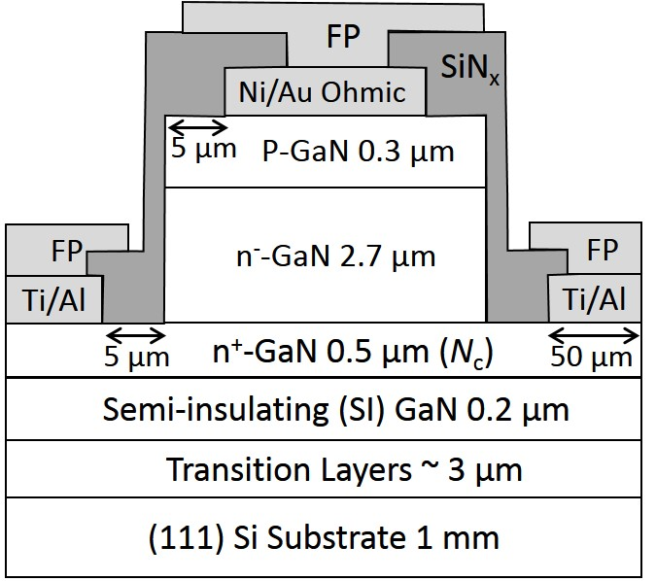
Fig. 1. Schematic cross sections of quasi-vertical GaN-on-Si pn diodes with passivation and field plate structures.

Fig. 4. (a) Forward I-V and differential R_{on} characteristics and (b) reverse I-V characteristics for the quasi- and fully-vertical GaN-on-Si pn diodes. (c) Forward I-V and differential R_{on} characteristics and (b) reverse I-V characteristics of the quasi-vertical GaN-on-Si pn diodes at 25-300 ºC. Similar high-temperature forward and reverse characteristics was observed for the fully-vertical pn diodes.
Fig. 5. R_{on} v.s. BV of GaN-on-Si vertical diodes demonstrated in this work and the ones in previous reports for GaN vertical diodes. The forward current density is extracted at the bias for differential R_{on} extraction.
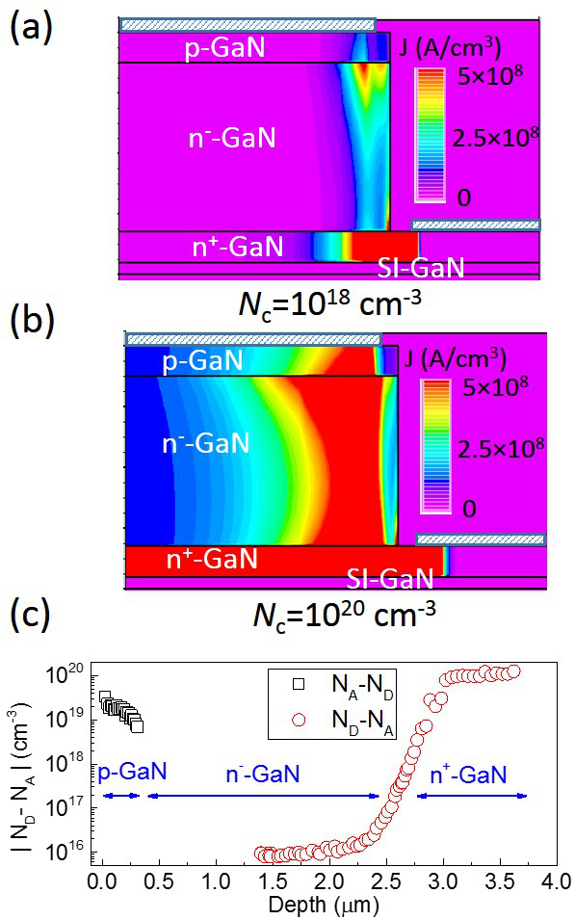
Fig. 2. (a) (b) Simulated forward current density distribution in quasi-vertical GaN-on-Si diodes with different doping levels in n⁺-GaN. (c) Net donor/acceptor concentration profile in the grown wafer, revealed by the electrochemical C-V measurement.

